|  |  |  |  |  |  |  |  |  |  |
| --- | --- | --- | --- | --- | --- | --- | --- | --- | --- |
|  | Bicubic interpolation | SRGAN-1 (50 epochs)  train, val | | SRGAN-1 (100 epochs)  train, val | | SRGAN-1 (150 epochs)  train, val | |  | |
| RMSE (wind, m/s) | 1,435 | 1,595 | 1,589 | 1,426 | 1,449 | 1,386 | 1,386 | 1,371 | 1,391 |
| RMSE (SLP, hPa) | 0,576 | 0,993 | 0,887 | 0,758 | 0,729 | 0,642 | 0,621 | 0,671 | 0,754 |
| RMSE-95 (m/s) | 1,898 | 2,555 | 2,621 | 2,194 | 2,298 | 2,106 | 2,189 | 2,079 | 2,188 |
| PSNR | 35,159 | 33,365 | 32,287 | 34,389 | 33,289 | 34,711 | 34,210 | 35,147 | 33,612 |

(1 January 2010 Low-Interp-High)

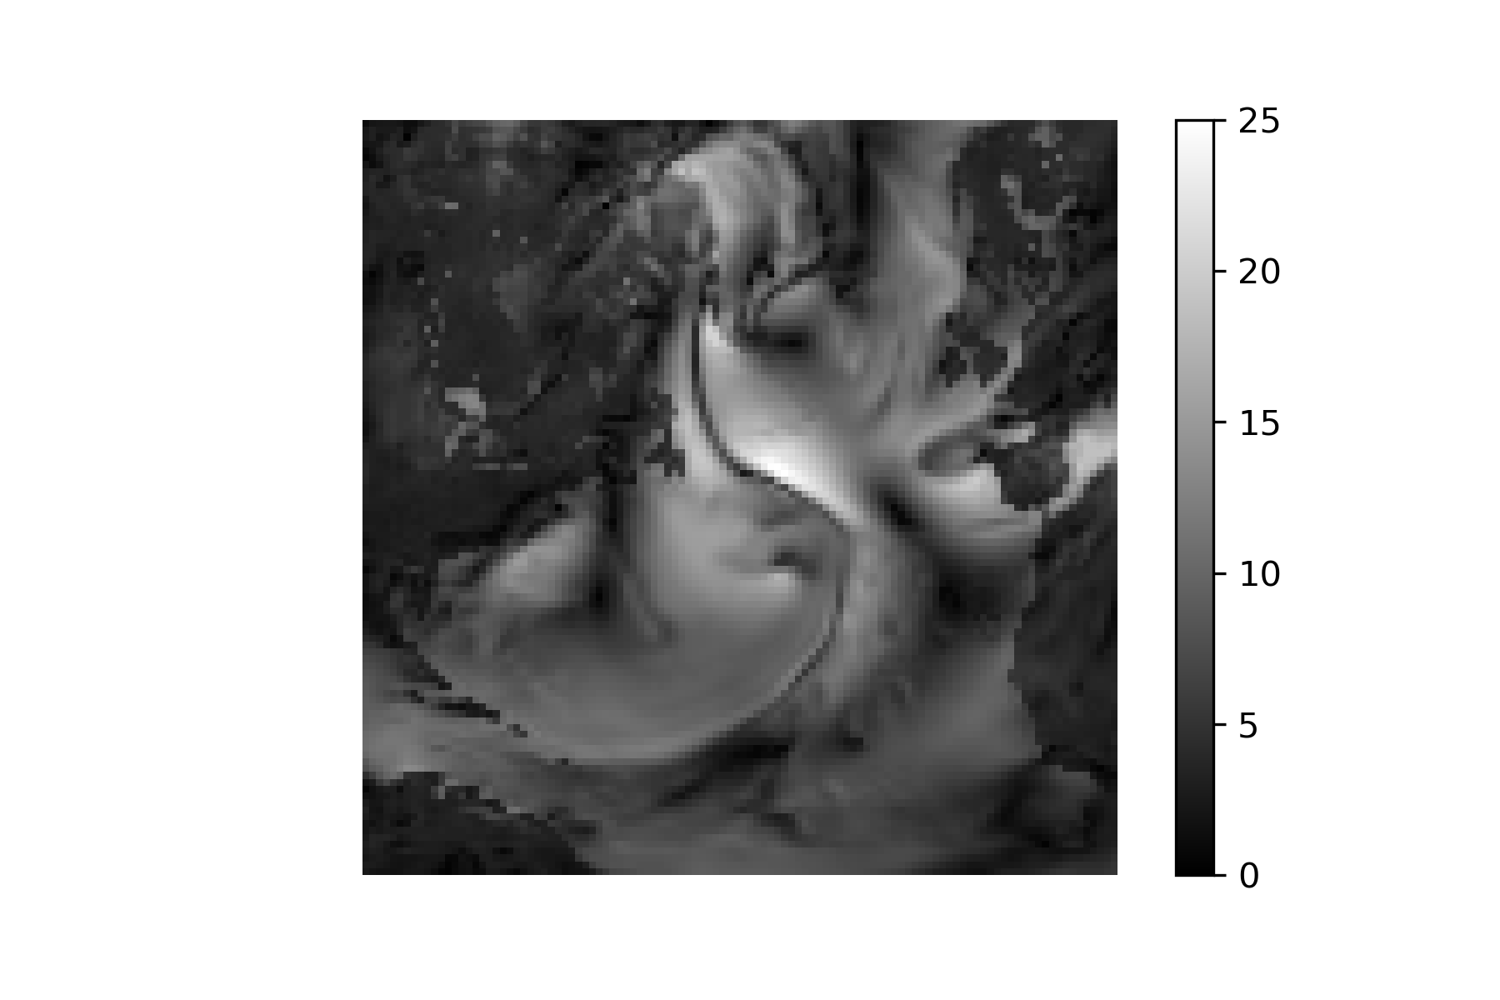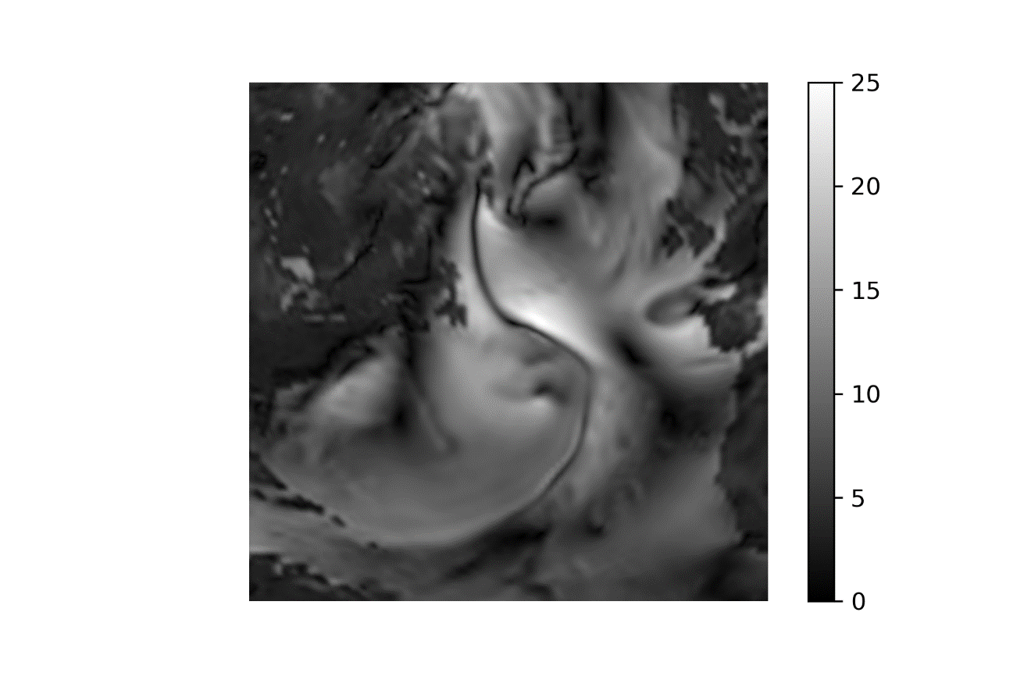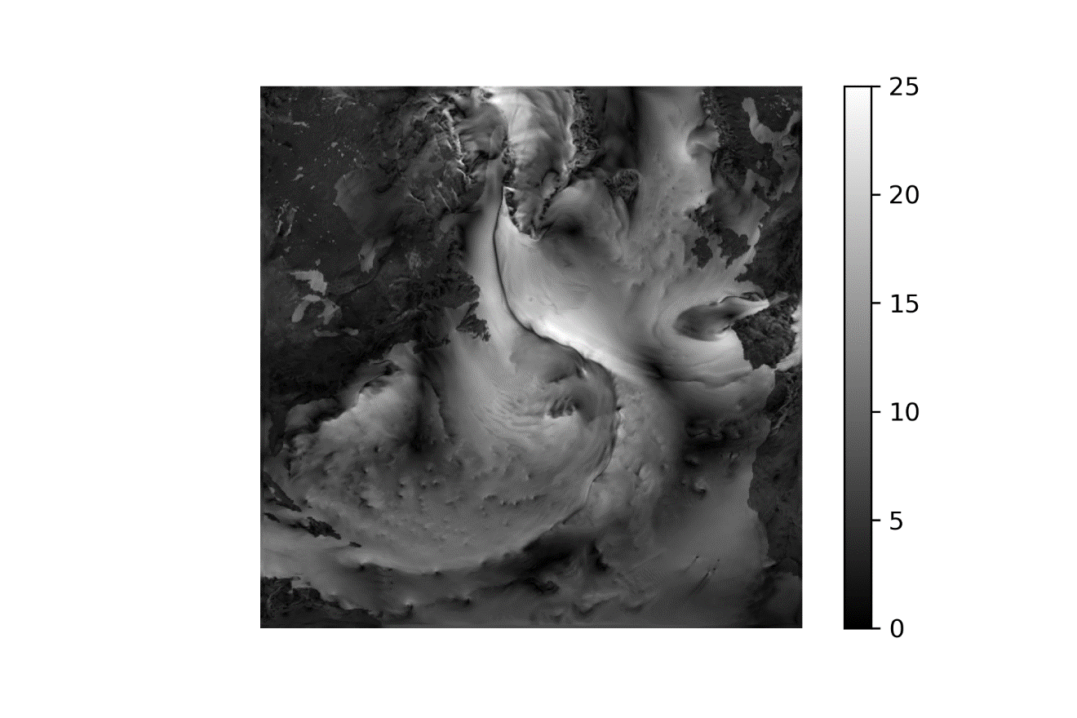

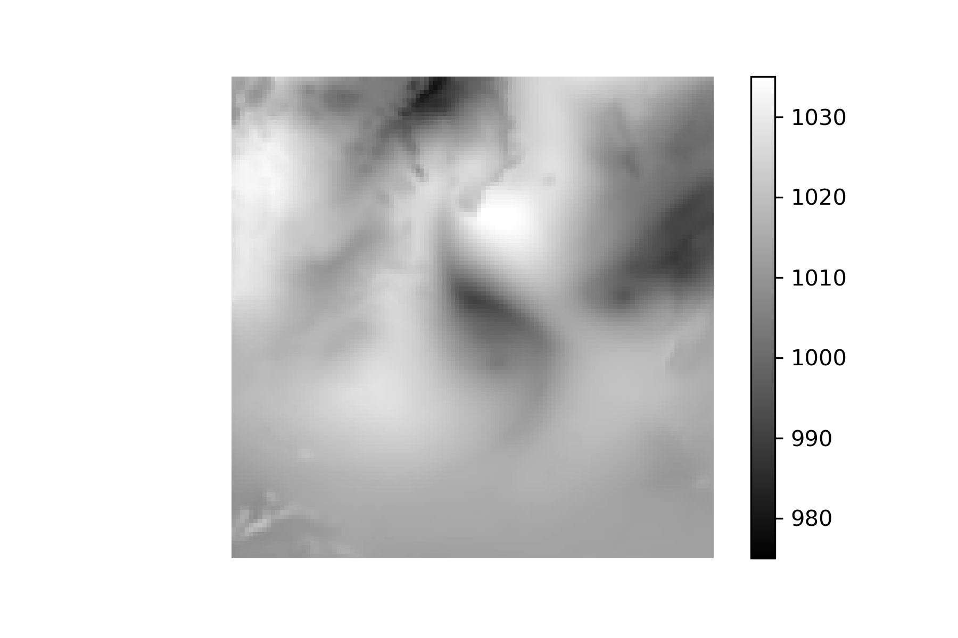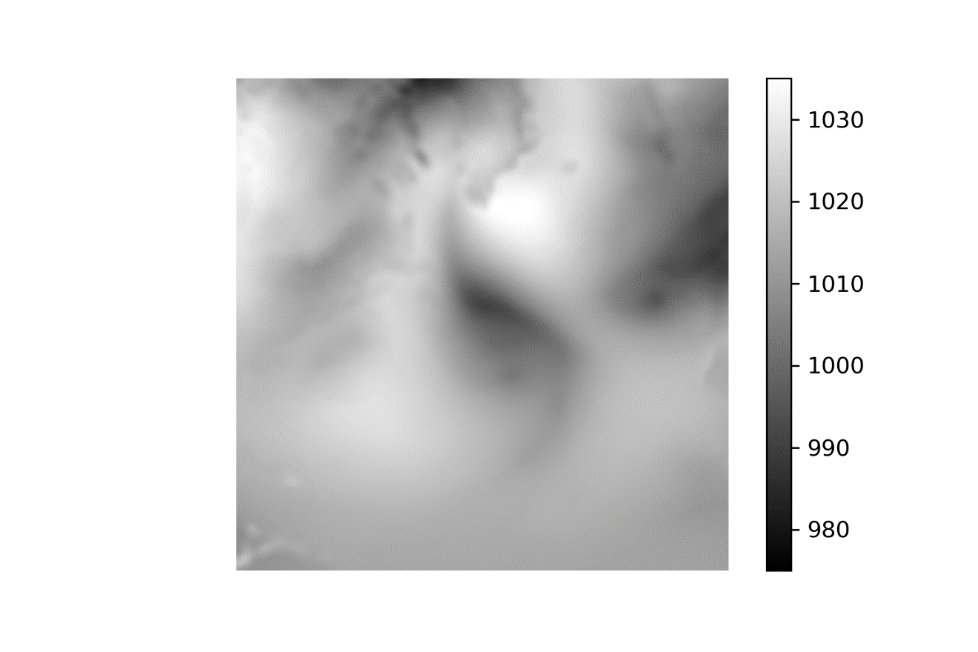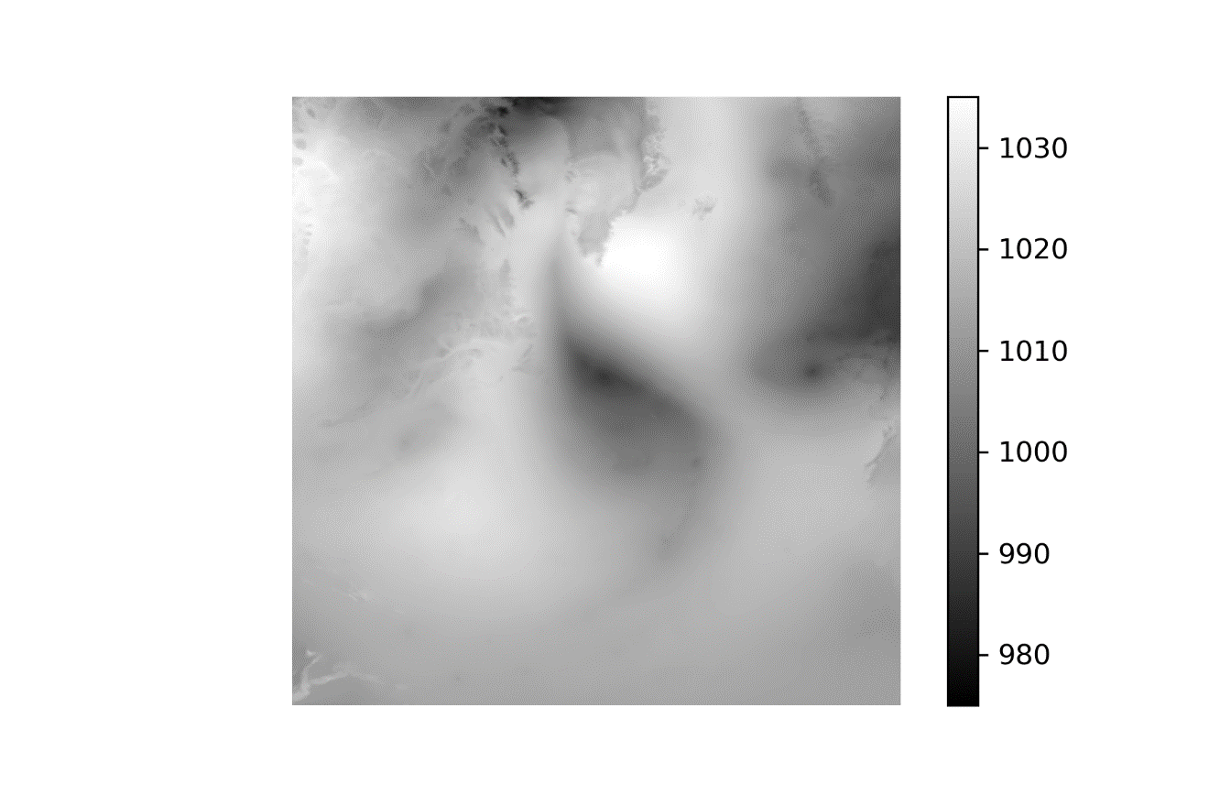

(1 Jul 2010 Low-Interp-High)

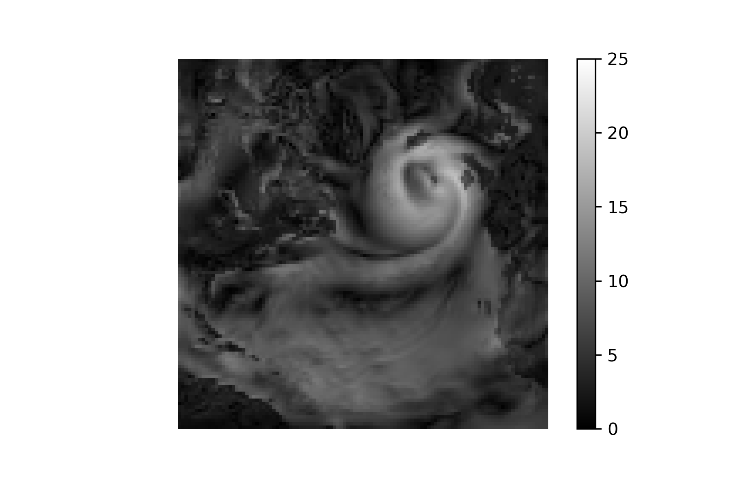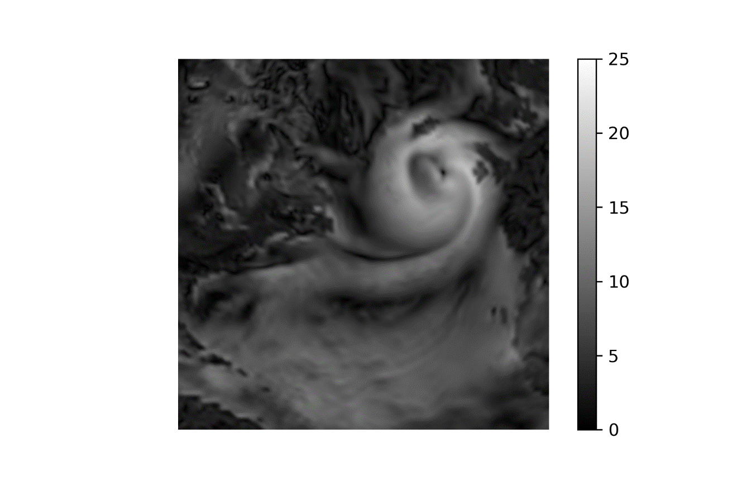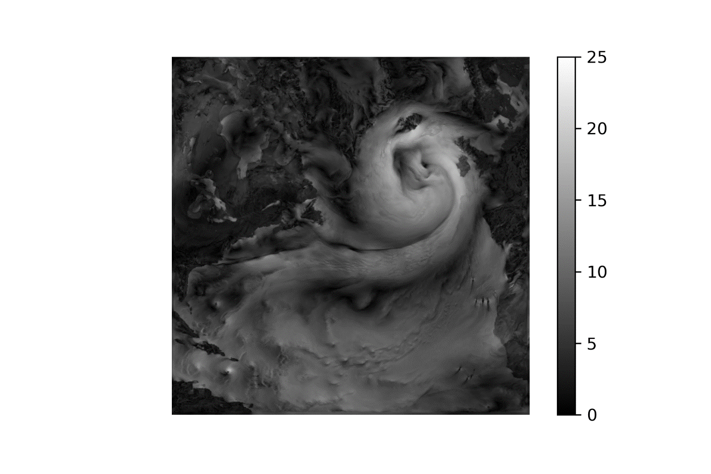

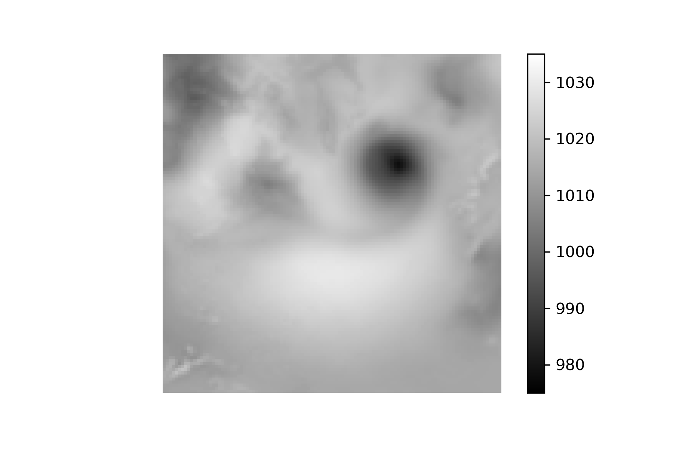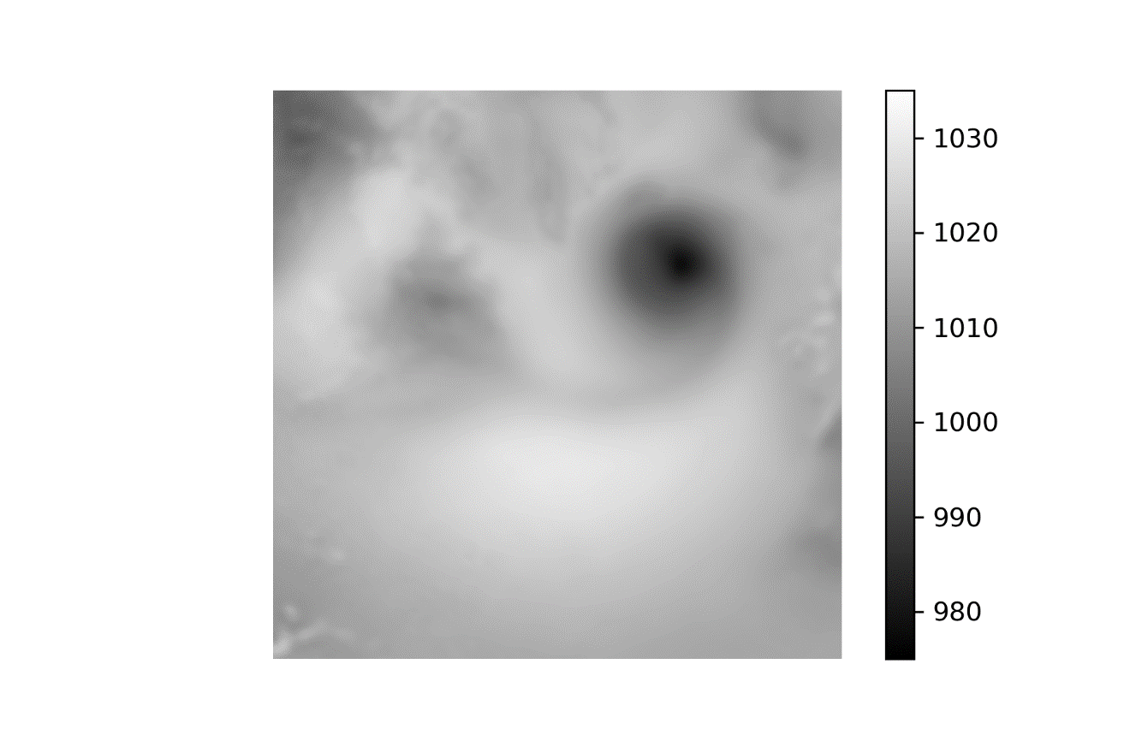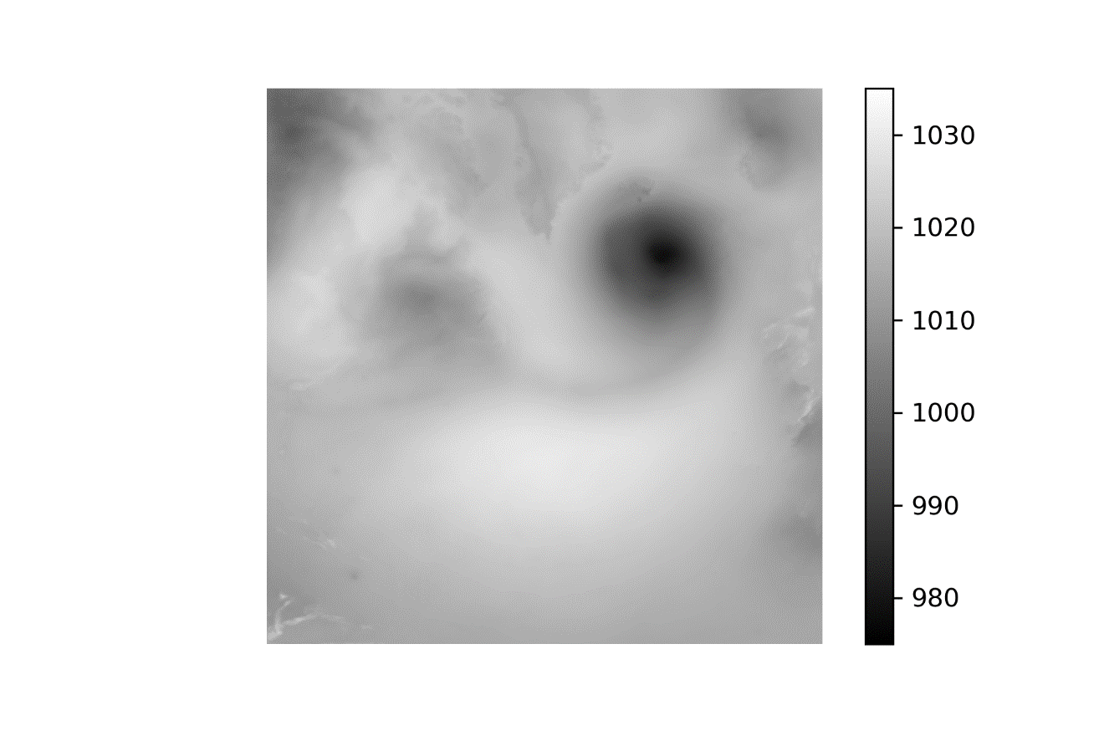

1 Jan 2010 –-50-100-150-200-High

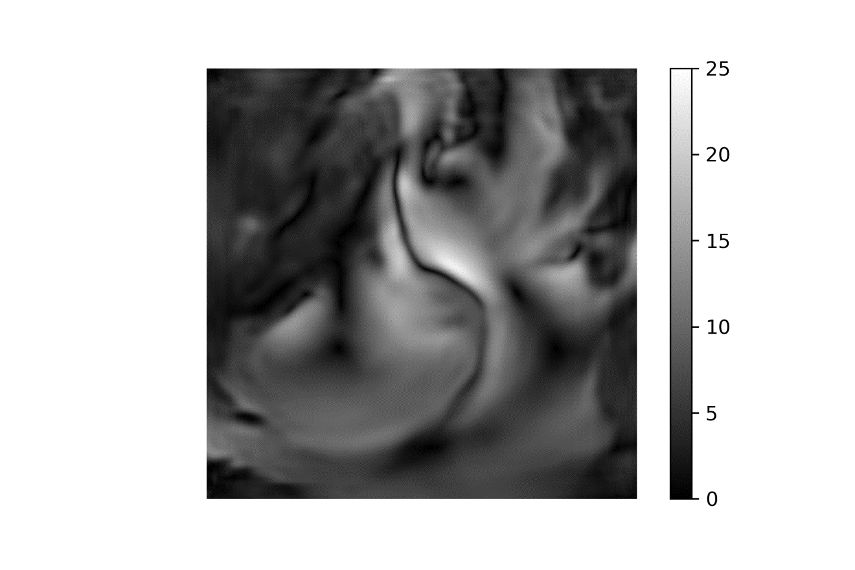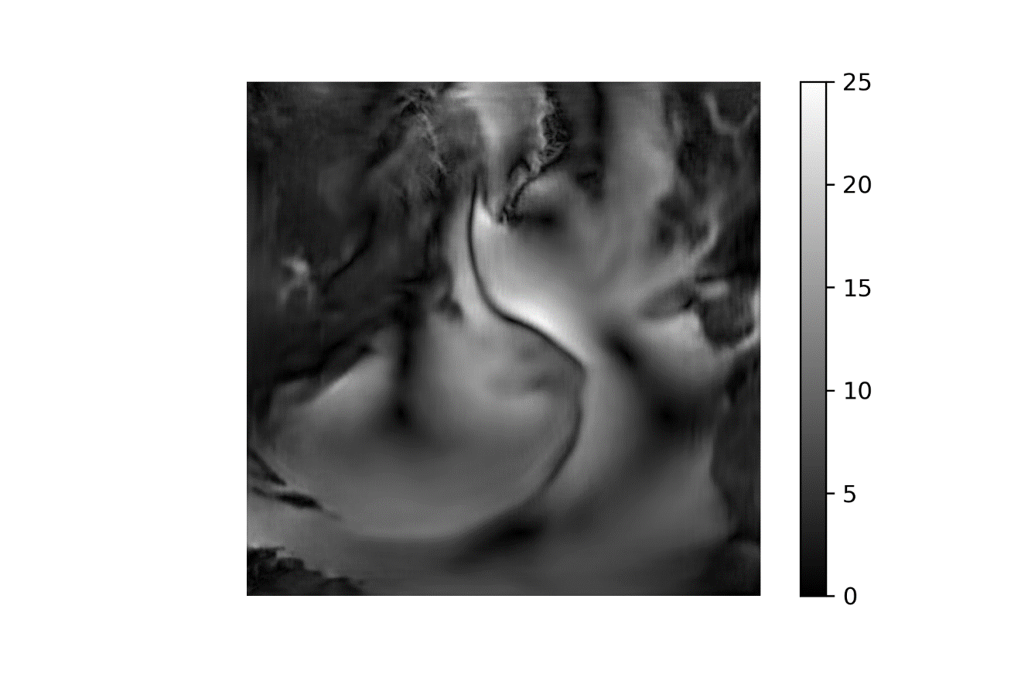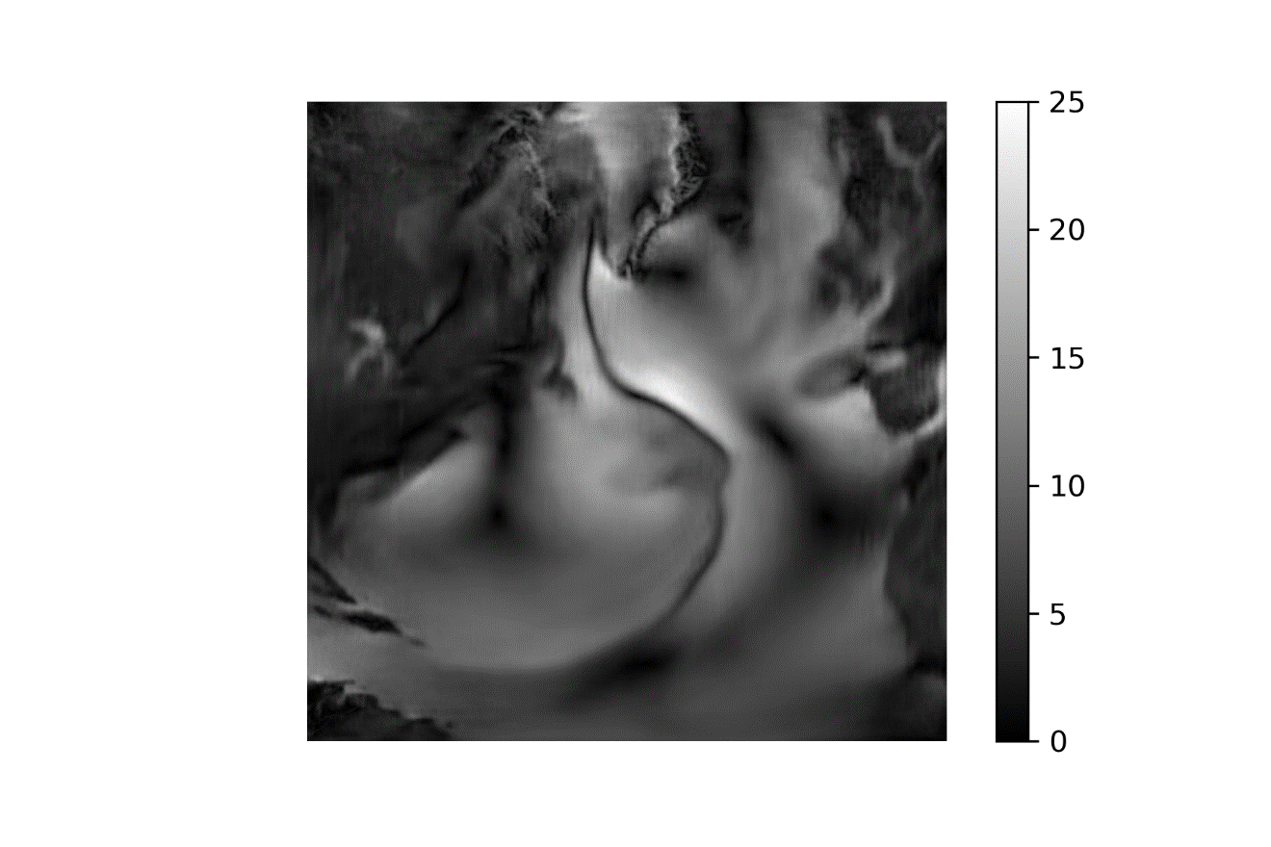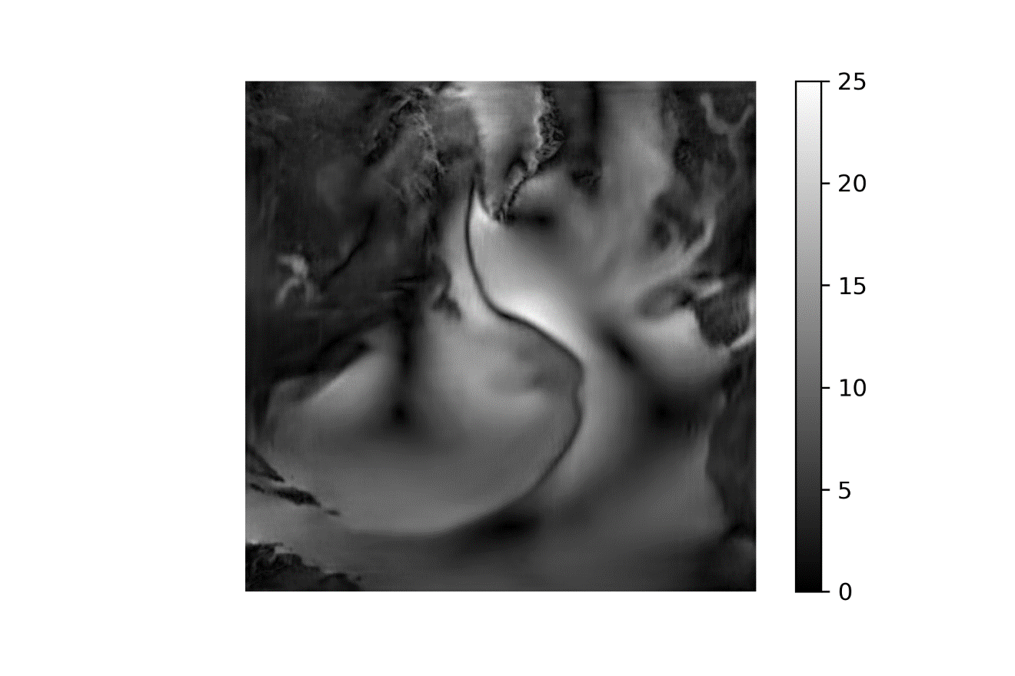

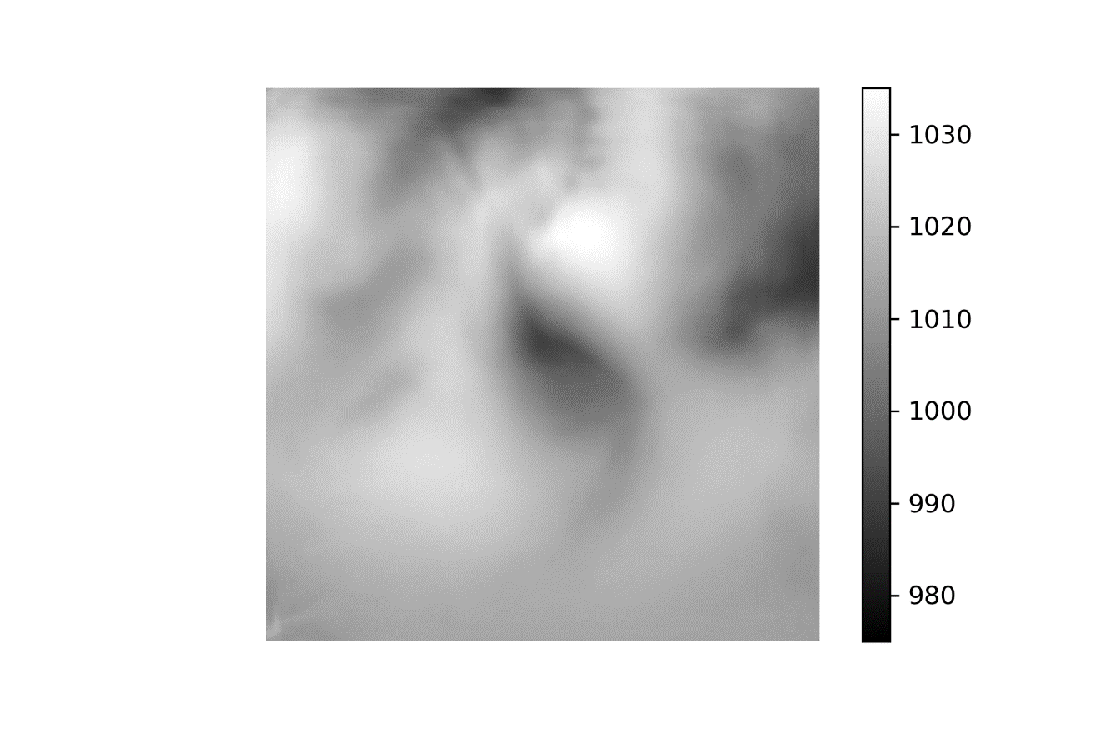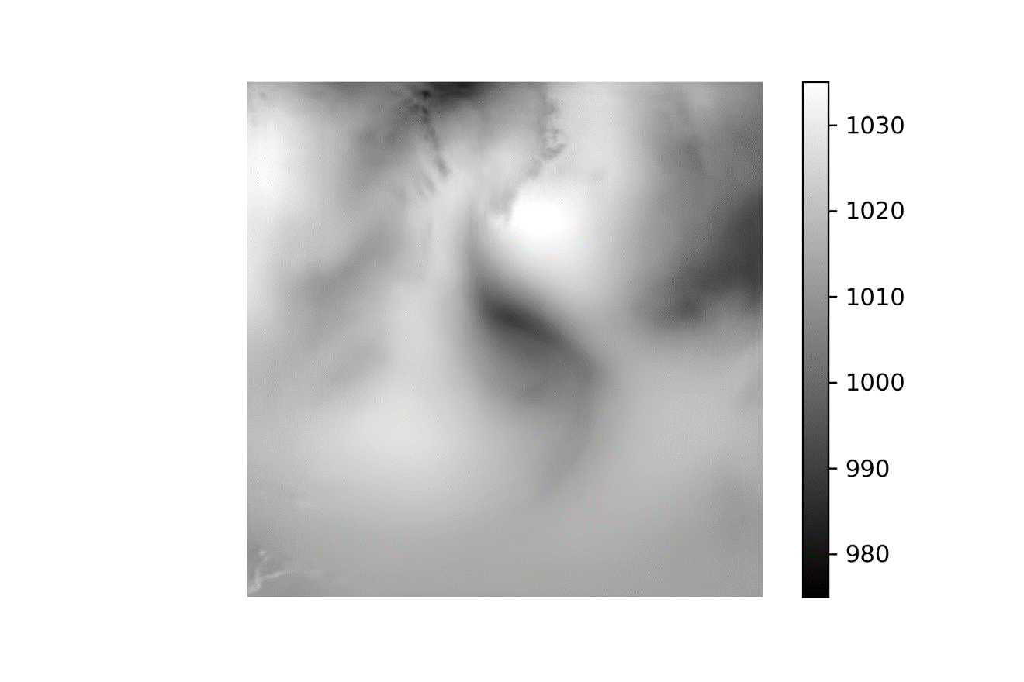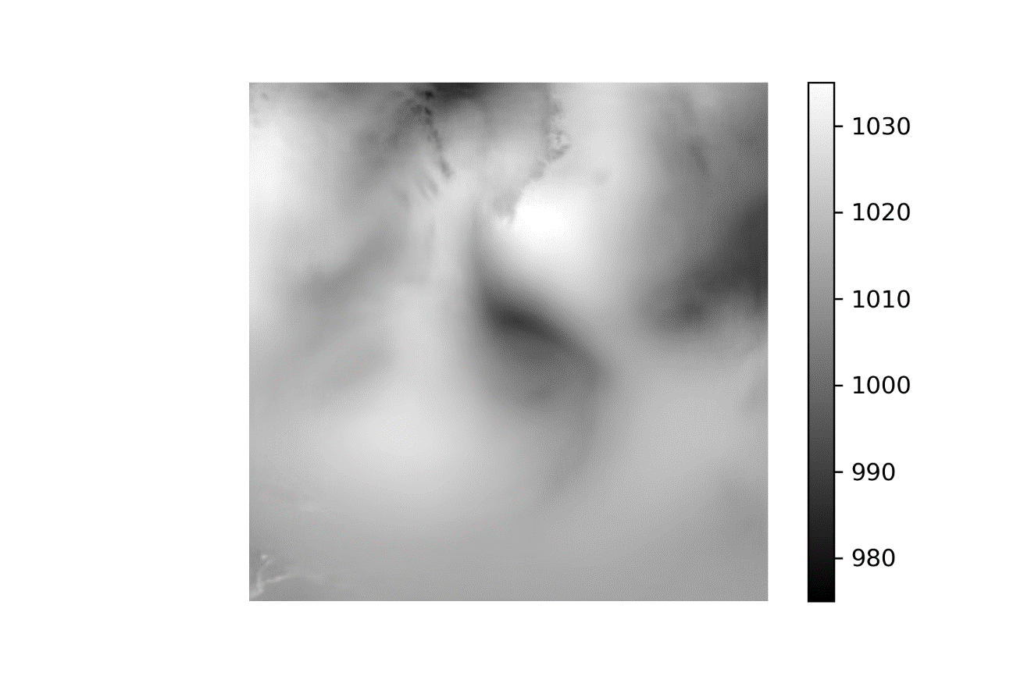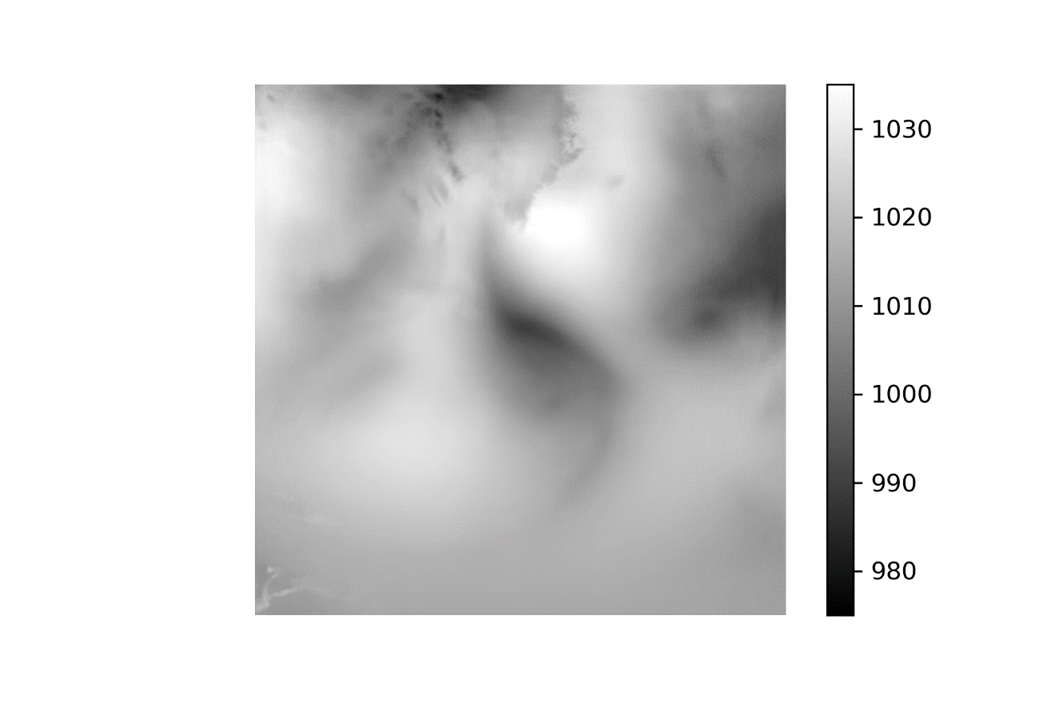

1 Jul 2010 –-50-100-150-200-High

